Using hydraulic geometry to remotely sense gas exchange velocity via the SWOT satellite

Craig B Brinkerhoff1,*, Colin J Gleason1, Christopher J Zappa2, Peter A Raymond3, and Merritt H Harlan1

1 Department of Civil & Environmental Engineering, University of Massachusetts-Amherst  
2 Lamont-Doherty Earth Observatory, Columbia University  
3 School of the Environment, Yale University

* Correspondence: [Craig B Brinkerhoff <[cbrinkerhoff@umass.edu](mailto:cbrinkerhoff@umass.edu)>](mailto:cbrinkerhoff@umass.edu)

## Key Points

* BIKER algorithm predicts gas exchange velocity and $CO_{2}$ fluxes from simulated SWOT data
* BIKER is robust to measurement errors implicit in SWOT river measurements
* BIKER will allow for unprecedented study of gas exchange spatiotemporal dynamics after SWOT’s launch

## Keywords

gas exchange, fluvial geomorphology, remote sensing, open-channel flow, SWOT, biogeochemistry

## Abstract

Extensive research over the past two decades has shown that the global river network emits significant amounts of greenhouse gas via evasion. Despite much progress, there is still significant uncertainty in the temporal dynamics of gas exchange velocity (i.e. the speed of evasion) and thus carbon emissions to the atmosphere. We propose that the NASA/CNES/USKA/CSA SWOT satellite, set to usher in a new age of hydrology research at the global scale, can provide similarly transformative insights to fluvial gas exchange modeling upon launch in 2022. Here, we present work inferring gas exchange velocity from future SWOT observations without in situ calibration. We exploit the unique geomorphology of SWOT-observable rivers to develop a physical model of gas exchange that is nearly entirely remotely sensible and explains 70% of variation in gas exchange. We then couple this model with established Bayesian inference techniques to develop BIKER, or the ‘Bayesian Inference of the $k_{600}$ Exchange Rate’ algorithm. We validate BIKER on 47 SWOT-simulated rivers and 763 discrete measurements of river gas exchange, yielding an algorithm that predicts this theoretical model solely from SWOT observations with a by-river median normalized RMSE of 32%. Like many fluvial Bayesian inference algorithms, BIKER is better at reproducing the temporal dynamics of gas exchange (median correlation coefficient of 0.95), rather than estimating the absolute rates of exchange. Finally, we show BIKER robust to measurement errors implicit in the SWOT data. With SWOT set to launch in late 2022, we suggest that BIKER can be deployed to map the global-scale spatiotemporal dynamics of fluvial gas exchange in large rivers.

## 1 Introduction

Natural systems play a critical role in the budgeting and accounting of the global carbon cycle under climate change. Following Cole et al. (2007), the global river network is recognized to emit substantial amounts of carbon to the atmosphere via evasion (gas exchange driven by a diffusion gradient and water turbulence), in addition to their long understood role of transporting carbon to the oceans. Current estimates of total carbon dioxide evasion ($FCO_{2}$) to the atmosphere from the global river network vary from 650-1800 Tg C/yr (Lauerwald et al., 2015; Raymond et al., 2013) (*Liu etal in review- add number is paper if accepted in time*), with 167 Tg-C/yr coming from mountain streams alone (Horgby et al., 2019). Despite rivers’ incredibly small percentage of the global land surface (0.47%- Raymond et al., 2013), this C flux is on par with the total oceanic $CO_{2}$ uptake rate (Gruber et al., 2019; Horgby et al., 2019) and the global forest carbon uptake rate (Pan et al., 2011).

River $CO_{2}$ evasion is increasingly better constrained and is clearly a critical component of the global carbon cycle. Equation 1 represents this riverine flux given $δCO_{2}$ (the gas concentration gradient between the water $CO_{2_{water}}$ and the air $CO_{2_{air}}$) and the gas exchange velocity *k*. Consult Appendix A for variable nomenclature used throughout this study.

$$FCO_{2}=k*δCO_{2}\left(1\right)$$

The structure of equation 1 necessitates that calculations of this flux are highly sensitive to measurements/estimates of *k*. However, *k* can only be directly calculated via a known gas concentration gradient, eddy-covariance measurements, or tracer additions to the stream (Hall & Ulseth, 2020). In trying to constrain the global fluvial $FCO_{2}$ flux across millions of rivers, this calculation is impossible, and necessitates the use of predictive models for *k* that are based on easily obtained river hydraulic properties. In that vein, there have been over 20 empirical models developed to predict *k*, generally using some combination of mean velocity $\overset{‾}{U}$, shear velocity $U_{*}$, width $W$, depth $H$, and slope $S$ as predictors (Wang et al., 2021). Note that these models usually predict $k_{600}$, or *k* normalized by a Schmidt number of 600. This is to remove the effect of water temperature and gas type from predictive models, as warmer waters and lower *Sc* numbers both increase gas exchange rates. For example, $k_{600}$ reflects the $k_{CO_{2}}$ at 20 degrees Celsius. Through this normalization, these models exclusively perturb the hydraulic controls on gas exchange (Hall & Ulseth, 2020).

These empirical models enable estimating a global $FCO_{2}$ flux ($FCO_{2_{upscaled}}$) by summing across millions of rivers, but they also change the base parameters that ultimately control that aggregate estimate. That is, by making *k* a function of hydraulics, $FCO_{2_{upscaled}}$ is now a direct function of river hydraulics. This functional relationship is described in equation 2. It suggests that $FCO_{2}$ estimates are not only at the mercy of the accuracy and spatiotemporal resolution of $δCO_{2}$, but also the accuracy and resolution of our river hydraulics estimates.

$$FCO_{2_{upscaled}}=f\left(k_{CO_{2}},δCO_{2}\right)=f\left(\overset{‾}{U},H,S,W,δCO_{2}\right)\left(2\right)$$

For example, to upscale $FCO_{2}$ globally, Raymond et al. (2013), Lauerwald et al. (2015), and Horgby et al. (2019) all relied on $k_{CO_{2}}$ values indirectly estimated using mean annual streamflow models and scaling equations to predict hydraulic terms, while Borges et al. (2015) used a combination of the above method and a constant $k_{CO_{2}}$ in space and time to upscale over Africa. In all of these foundational studies, the temporal dynamics of the gas exchange velocity (and thus $FCO_{2}$) were ignored because of hydraulic data limitations. It has been shown at the field-scale that temporal dynamics of gas exchange can vary widely from site to site (Wallin et al., 2011), but it has remained impractical to obtain temporally explicit $k_{CO_{2}}$ at continental-to-global scales. This knowledge gap is contrasted agaist the robust existing literature exploring spatiotemporal patterns in $CO_{2_{water}}$ (e.g. Crawford et al., 2017; Peter et al., 2014; Ran et al., 2017; Raymond et al., 2000; Rocher-Ros et al., 2019).

To that end, the field has made significant progress in estimating $CO_{2_{water}}$, where we now have river-reach explicit modeling at monthly temporal resolutions using global hydrography datasets [Horgby et al. (2019); Brinkerhoff et al. (2021); Saccardi & Winnick (2021); *Liu etal in review*], but an equivalently sophisticated representation of $k_{CO_{2}}$ is still lacking. As equations 1 and 2 dictate, these terms share the burden of calculating $FCO_{2}$. Therefore, these next-generation models will have to contend with this discrepancy, which is directly dictated by the lack of direct measurements of global river hydraulics.

Wang et al. (2021) recently attempted to address this problem by simulating *k* in 35 rivers of many sizes (widths ranging from 0.23–349m) using a stream metabolism model (Appling et al., 2018) and in situ dissolved oxygen (DO) datasets to infer what *k* must have been. They then compared this simulated dataset against direct measurements of *k*, finding similar performance and parameter values for process-based models of gas evasion. However, they were still limited by a lack of direct hydraulic measurements and had to rely on scaling equations to estimate river depth and velocity. Even though approaches like this are incredibly useful for expanding our mechanistic understanding of gas exchange, it is less useful for global upscaling purposes as it relies on highly detailed in situ DO data.

In theory, this discrepancy between the quality of our $CO_{2_{water}}$ and $k_{CO_{2}}$ estimates could be alleviated if direct hydraulics measurements were available at the global scale at a sufficient temporal resolution. This is turn would also address the uncertainty regarding continental-to-global scale temporal dynamics of gas exchange noted earlier. Conveniently, these very data will soon be available via the upcoming NASA/CNES/UKSA/CSA Surface Water and Ocean Topography (SWOT) satellite mission. SWOT is expected to launch in 2022 and provide the world’s first direct measurements of global water surface extent and elevation at novel temporal resolutions. SWOT is a wide swath radar interferometer and will sample rivers every 1 to 7 days per 21 day repeat cycle, measuring rivers wider than 100m with a goal of expanding this to rivers at least 50m wide (Biancamaria et al., 2016). Via its direct hydraulic measurements, SWOT is expected to usher in a sea change in global-scale hydrology, and could similarly transform fluvial biogeochemsitry if techniques are developed to ingest SWOT data and infer *k*. Here, we borrow tools from fluvial geomorphology and existing SWOT algorithms to answer the following two questions:

* Can we leverage the hydraulic geometry of the large rivers SWOT will observe to develop a physically-based model for $k_{600}$ unique to these rivers?
* Can we exploit such a model to infer $k_{600}$ (and its uncertainty) solely from SWOT observations?

To answer this first question, we use the specific hydraulic geometry of large, SWOT-observable rivers to develop a process-based model for large-river gas exchange. We then take these findings and explore question 2 by implementing the model within an RS of $k_{600}$ algorithm named BIKER (‘Bayesian Inference of the $k_{600}$ Evasion Rate’). The goal with BIKER is to require no in situ inputs of any kind (although in situ data could be ingested and should improve results) such that it is completely globally implementable on any river on Earth that SWOT will measure. Finally, we also test whether BIKER can predict actual gas fluxes when paired with an in situ $CO_{2}$ sensor and compare it against established methods that are reliant on in situ hydraulic measurements.

This paper is split into two distinct parts: gas-exchange theory/model development (section 2) and BIKER algorithm development/validation (section 3). Section 3 is fundamentally dependent on the results presented in section 2, therefore section 2 presents both theory and results. Both sections detail the data used. We conclude with a discussion (section 4) that encompasses both gas exchange theory and remote sensing. We also provide a flowchart detailing the entire study as Figure 1.

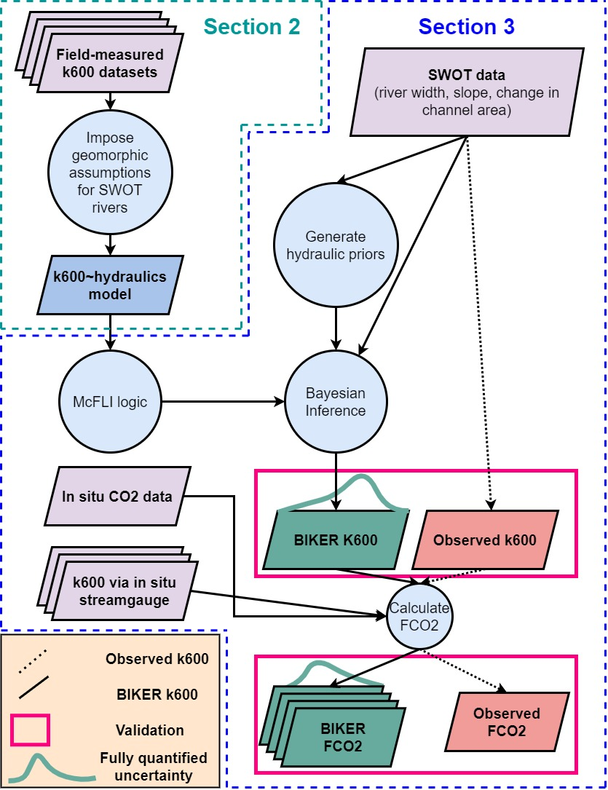

Figure 1: Flowchart detailing entire study. Dashed lines indicate workflow to calculate the observed data that we validate against. See Appendix A for variable nomenclature used in this study.

## 2 Hydraulic geometry in large rivers and predicting fluvial gas exchange velocity

To predict *k* in the very large rivers that SWOT will observe, we start from established process-based models for *k*, impose hydraulic assumptions that are valid in large rivers, and then obtain a suite of models we can test. Following a description of the data used (section 2.1), we outline these established models (section 2.2) and then step through our hydraulic assumptions to arrive at equations that can be ingested by SWOT (section 2.2). Following this model development, all models are empirically tested (section 2.3)

### 2.1 Data

Our gas exchange theory is developed using multiple datasets of directly measured $k_{600}$ and directly measure stream hydraulics collected from the literature. In total, we have collected 763 measurements of $k_{600}$, with 701 of these measurements previously published by Raymond et al. (2012) and Ulseth et al. (2019). These come from tracer studies and thus define $k_{600}$ and the rivers’ mean hydraulic properties at the reach scale. The remaining measurements were measured by Churchill et al. (1964) and Owens et al. (1964). See Table S1 for a complete list of the studies that collected these measurements.

We expand our dataset of stream hydraulics using a previously published compilation of in situ hydraulic measurements (Brinkerhoff et al., 2019). That dataset contains over 530,000 unique measurements of river channel velocity, width, and discharge from across the continental United States, originally taken to calibrate United States Geological Survey (USGS) streamgauge rating curves and made public by the USGS. Ultimately, this dataset was filtered to 172316 discrete measurements for this study, in addition to the direct measurements in the gas exchange dataset (see Text S1 for our filtering protocol).

### 2.2 Process-based modeling of river *k*

*k* should scale with near-surface turbulence in a turbulent flow (Hall & Ulseth, 2020) and thus extensive field and laboratory experiments have converged on the ‘small-eddy model’ as first proposed by Lamont & Scott (1970) *Zappa said this actually goes back further than this paper* to scale *k* via the smallest-scale turbulent eddies (e.g. Katul et al., 2018; Lorke & Peeters, 2006; Moog & Jirka, 1999b; Tokoro et al., 2008; Vachon et al., 2010; Wang et al., 2021; Zappa et al., 2003, 2007). This model is provided as equation 3, where $ϵ$ is the dissipation rate of near-surface turbulence, $v$ is the kinematic viscosity, and *Sc* is the Schmidt number.

$$k∝Sc^{−1/2}{\left(vϵ\right)}^{1/4}\left(3\right)$$

Further, some workers have noted that laboratory and field observations suggest open channel flows with small bed roughness (generally big rivers) do not exhibit homogeneous surface dissipation at their air-water interface (Moog & Jirka, 1999a; Talke et al., 2013). Given this observation, Moog & Jirka (1999a) proposed an extension to the small-eddy model, additionally scaling $k_{600}$ using a shear Reynold’s number formulation. *look up other shear reynolds ways to additionally scale k*. This is equation 4 and is referred to as the ‘Chainsaw model’. The Chainsaw model is hypothetically useful in low-turbulence flows where a relative lack of large-scale eddies effectively ‘filter out’ the number of small-eddies that actually reach the interface and lead to gas exchange (Talke et al., 2013). In the context of BIKER, we chose to test this model because large, SWOT-observable rivers are generally the smoothest, least-turbulent flows along the stream-to-river continuum. Further, to our knowledge the chainsaw model has never been empirically tested in predicting *k*, aside from confirming that large-scale eddies differentially move turbulence to the surface in a hydraulically-wide river (Talke et al., 2013).

$$k∝Sc^{−1/2}{\left(vϵ\right)}^{1/4}{\left(\frac{U_{*}H}{v}\right)}^{3/8}\left(4\right)$$

Finally, both equations rely on measurements of $ϵ$, of which measuring directly is non-trivial. When working at large scales, a commonly used $ϵ$ model assumes that all turbulence is generated at the bed and transported to the air-water interface via the log-law-of-the-wall such that $ϵ=ϵ_{S}=\frac{U_{*}^{3}}{H}$ (Lorke & Peeters, 2006; Nezu & Nakagawa, 1993). Another approach models *k* via ‘form-drag dissipation’ ($ϵ=ϵ_{D}=gS\overset{‾}{U}$) which is equivalently the total stream power per unit mass water. This normalized stream power captures the bulk frictional resistance (and thus energy dissipation) via channel banks, meanders, bars, etc. that is unique to fluvial systems (Moog & Jirka, 1999b). Authors have since shown that this model can reasonably predict *k* in rivers and streams (Raymond et al., 2012; Ulseth et al., 2019; Wang et al., 2021).

### 2.3 Imposing large-river hydraulic geometry

Rivers and streams change predictably along their longitudinal profile from headwater to ocean, and we can exploit the distinct hydraulic geometry of large rivers at the end of this continumn to estimate *k* in SWOT-observable systems. In general, as river size increases, channels become more rectangular, their shapes elongate (becoming wider quicker than they become deeper) and their hydraulic radii begin to approximate their mean flow depth, i.e. $R_{h}≈H$  (Leopold & Maddock, 1953). This is a common assumption in hydraulic and geomorphic modeling of large rivers, and occurs in 89% of our SWOT-observable river measurements but only 65% of non-SWOT observable river measurements (calculated using both datasets of stream hydraulics outlined in section 2.1- see Text S1 for full details). These channels are often referred to as ‘hydraulically-wide’.

Assuming that all SWOT-observable rivers are hydraulically-wide, we test the performance of four models for predicting *k* in hydraulically-wide channels: the four unique combinations of equations 3-4 and the two $ϵ$ models already outlined. While the complete model derivations for the small-eddy models (section 2.3.1) and the chainsaw models (section 2.3.2) are provided in Text S2, the broad goal was to reduce the equations down to their fundamental parameters, identifying which terms are SWOT observable and limiting the number of terms not directly measurable via SWOT.

#### 2.3.1 ‘Small-eddy’ model for gas evasion

We derive equations starting from the small-eddy model (equation 3) for hydraulically-wide channels. If we assume $ϵ=ϵ_{S}$ and $R_{H}=H$ in equation 2, and finally solve for $k_{600}$ via statistical parameter $α$, we eventually arrive at equation 5. If we do the same but assume $ϵ=ϵ_{D}$ and statistical parameter $α_{1}$, we arrive at equation 6.

$$k_{600}=α{\left(gS\right)}^{3/8}H^{1/8}\left(5\right)$$

$$k_{600}=α_{1}{\left(gS\overset{‾}{U}\right)}^{1/4}\left(6\right)$$

Equations 5 and 6 thus define gas exchange velocity solely as a function of slope and mean flow depth or mean flow velocity. This is theoretically valid only in a hydraulically-wide channel.

#### 2.3.2 ‘Chainsaw’ model for gas evasion

We also impose $ϵ=ϵ_{S}$ and $R_{H}=H$ on the chainsaw model just like we did in section 2.3.1 and arrive at equation 7 (with statistical coefficient $β$). The result is identical to the hydraulically-wide small-eddy model (equation 5), except for the exponents which are both steeper. Equation 8 reflects the same derivation, but when $ϵ=ϵ_{D}$ and statistical coefficient $β_{1}$.

$$k_{600}=β{\left(gS\right)}^{9/16}H^{11/16}\left(7\right)$$

$$k_{600}=β_{1}{\left(gS\right)}^{7/16}{\overset{‾}{U}}^{1/4}H^{9/16}\left(8\right)$$

We now have four different models for $k_{600}$ in hydraulically-wide rivers, each with a different set of assumptions and parameters but all defined as functions of the water surface slope and other hydraulic terms that are not directly measurable via SWOT. All four models are summarized in Table 1.

*Table 1: Four physically-based models for $k_{600}$ each derived under a different set of mass transport assumptions but all valid in hydraulically-wide rivers. Their derivations are outlined in sections 3.2.1 and 3.2.2 and their empirical tests are shown in section 3.3.*

| **Description** | **Equation** | **References** | **Empirical test** | **Empirical fit via $r^{2}$** |
| --- | --- | --- | --- | --- |
| Small-eddy, log-law-of-the-wall | $k_{600}=α{\left(gs\right)}^{3/8}H^{1/8}$ | Lamont & Scott (1970); log-law-of-the-wall | Figure 3a | 0.61 |
| Small-eddy, form-drag dissipation | $k_{600}=α_{1}{\left(gS\overset{‾}{U}\right)}^{1/4}$ | Lamont & Scott (1970); Moog & Jirka (1999b) | Figure 3c | 0.63 |
| Chainsaw, log-law-of-the-wall | $k_{600}=β{\left(gs\right)}^{9/16}H^{11/16}$ | Moog & Jirka (1999a); log-law-of-the-wall | Figure 3b | 0.66 |
| Chainsaw, form-drag dissipation | $k_{600}=β_{1}{\left(gs\right)}^{7/16}{\overset{‾}{U}}^{1/4}H^{9/16}$ | Moog & Jirka (1999a); Moog & Jirka (1999b) | Figure 3d | 0.7 |

### 2.4 Model validation

With equations 5-8 defined, we now empirically test their strength of fit for hydraulically-wide channels. We validate on the dataset of direct measurements of $k_{600}$ and stream hydraulics, after filtering for measurements made in hydraulically-wide channels. This was defined here as those whose hydraulic radius was within 1% of their mean flow depth. All told, this amounts to 166 *double check* direct measurements of hydraulically-wide $k_{600}$ and stream hydraulics to test with. Models were assesed via the coefficient of determination ($r^{2}$) and results are plotted in Figure 3. Note that Figure 3 axes are plotted in logarithmic space just for visualization: model fit and validation (via $r^{2}$) were calculated in linear space as their models dictate.

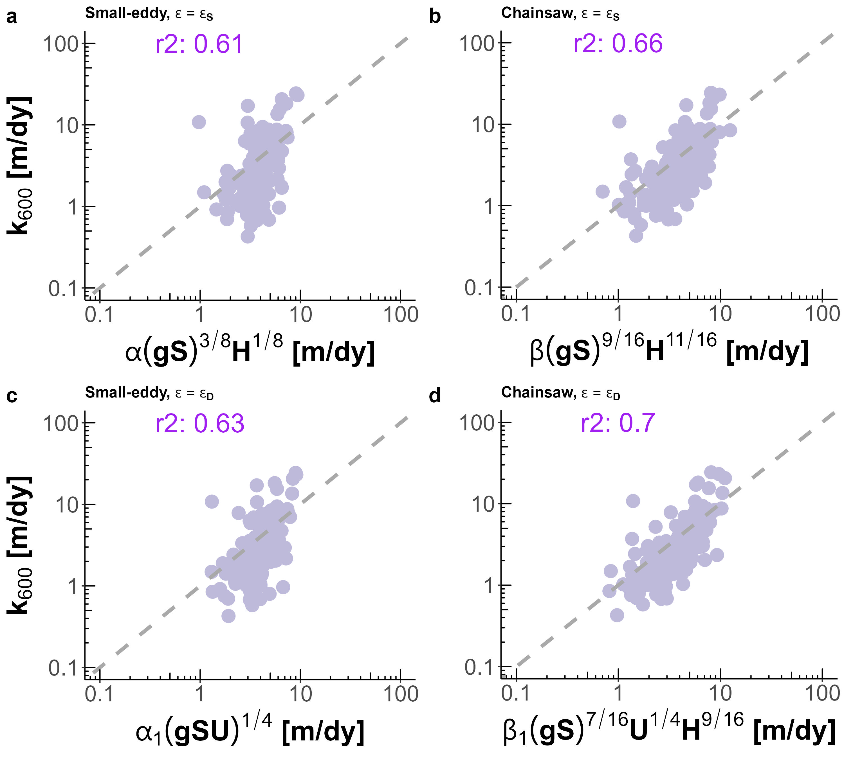

Figure 2: Empirical testing of four models for predicting gas exchange velocity in hydraulically-wide channels: (a) Small-eddy model with log-law-of-the-wall dissipation. (b) Chainsaw model with log-law-of-the-wall dissipation. (c) Small-eddy model with form-drag dissipation. (d) Chainsaw model with form-drag dissipation. Note that axes are plotted in logarithmic space just for visualization: model fit and validation were calculated in linear space.

Despite reasonable $r^{2}$ scores, both small-eddy models produce clearly biased estimates (Figures 3a, 3c). They systematically underestimate lower gas exchange velocities and overestimate higher ones, with the log-law-of-the-wall model (Figure 3a) performing marginally worse both visually and via $r^{2}$ (0.61 versus 0.63 for Figure 3c). However, when this model is expanded to retard the dissipation rate in the smoothest flows via the Chainsaw model (equations 6 and 7- Moog & Jirka, 1999a), the dynamics are more accurately captured (Figures 3b, 3d) and $r^{2}$ scores go up appreciably (0.66 and 0.7 for the log-law-of-the-wall and form-drag dissipation, respectively). Modeling dissipation via total form-drag rather than just via bed shear and the log-law-of-the-wall improves model performance. This is likely because the majority of dissipation occurring in rivers comes not just from the streambed, but from bulk form drag via channel walls, bars, and meanders (Moog & Jirka, 1999b; Raymond et al., 2012; Ulseth et al., 2019; Wang et al., 2021).

The success of the chainsaw model in hydraulically-wide channels, and in particular when coupled with the $ϵ=ϵ_{D}$ model (equation 8, Figure 3d), provides us with a strong physical-model for gas evasion. The river hydraulics terms in equation 8 can either be directly measured or reasonably inferred from SWOT measurements, effectively opening the door for remotely sensing the gas exchange velocity. This is explored next.

## 3 Exploiting equation 8 to remotely sense gas exchange velocity

We have shown that scaling $k_{600}$ via equation 8 explains 70% of the variation in $k_{600}$ in hydraulically-wide rivers, which includes nearly all SWOT-observable rivers. Further, equation 8 has only three non-remotely-sensible terms: $k_{600}$, mean flow depth, and mean flow velocity. Conveniently, techniques to simultaneously infer hydraulic parameters from SWOT data have been established over the last decade to infer streamflow from SWOT’s measurements (e.g. Andreadis et al., 2020; Brinkerhoff et al., 2020; Brisset et al., 2018; Durand et al., 2014; Garambois et al., 2020; Garambois & Monnier, 2015; Gleason et al., 2014; Hagemann et al., 2017; Larnier et al., 2020; Oubanas et al., 2018). For BIKER, we follow the work developed by Durand et al. (2014), Hagemann et al. (2017), and Brinkerhoff et al. (2020) to infer mean flow velocity and depth from SWOT observations using a modified form of the Manning’s equation for mean flow velocity. Following a description of the data used (section 3.1), we detail algorithm development and experimental design (section 3.2) and then we present the validation results (section 3.3).

### 3.1 Data

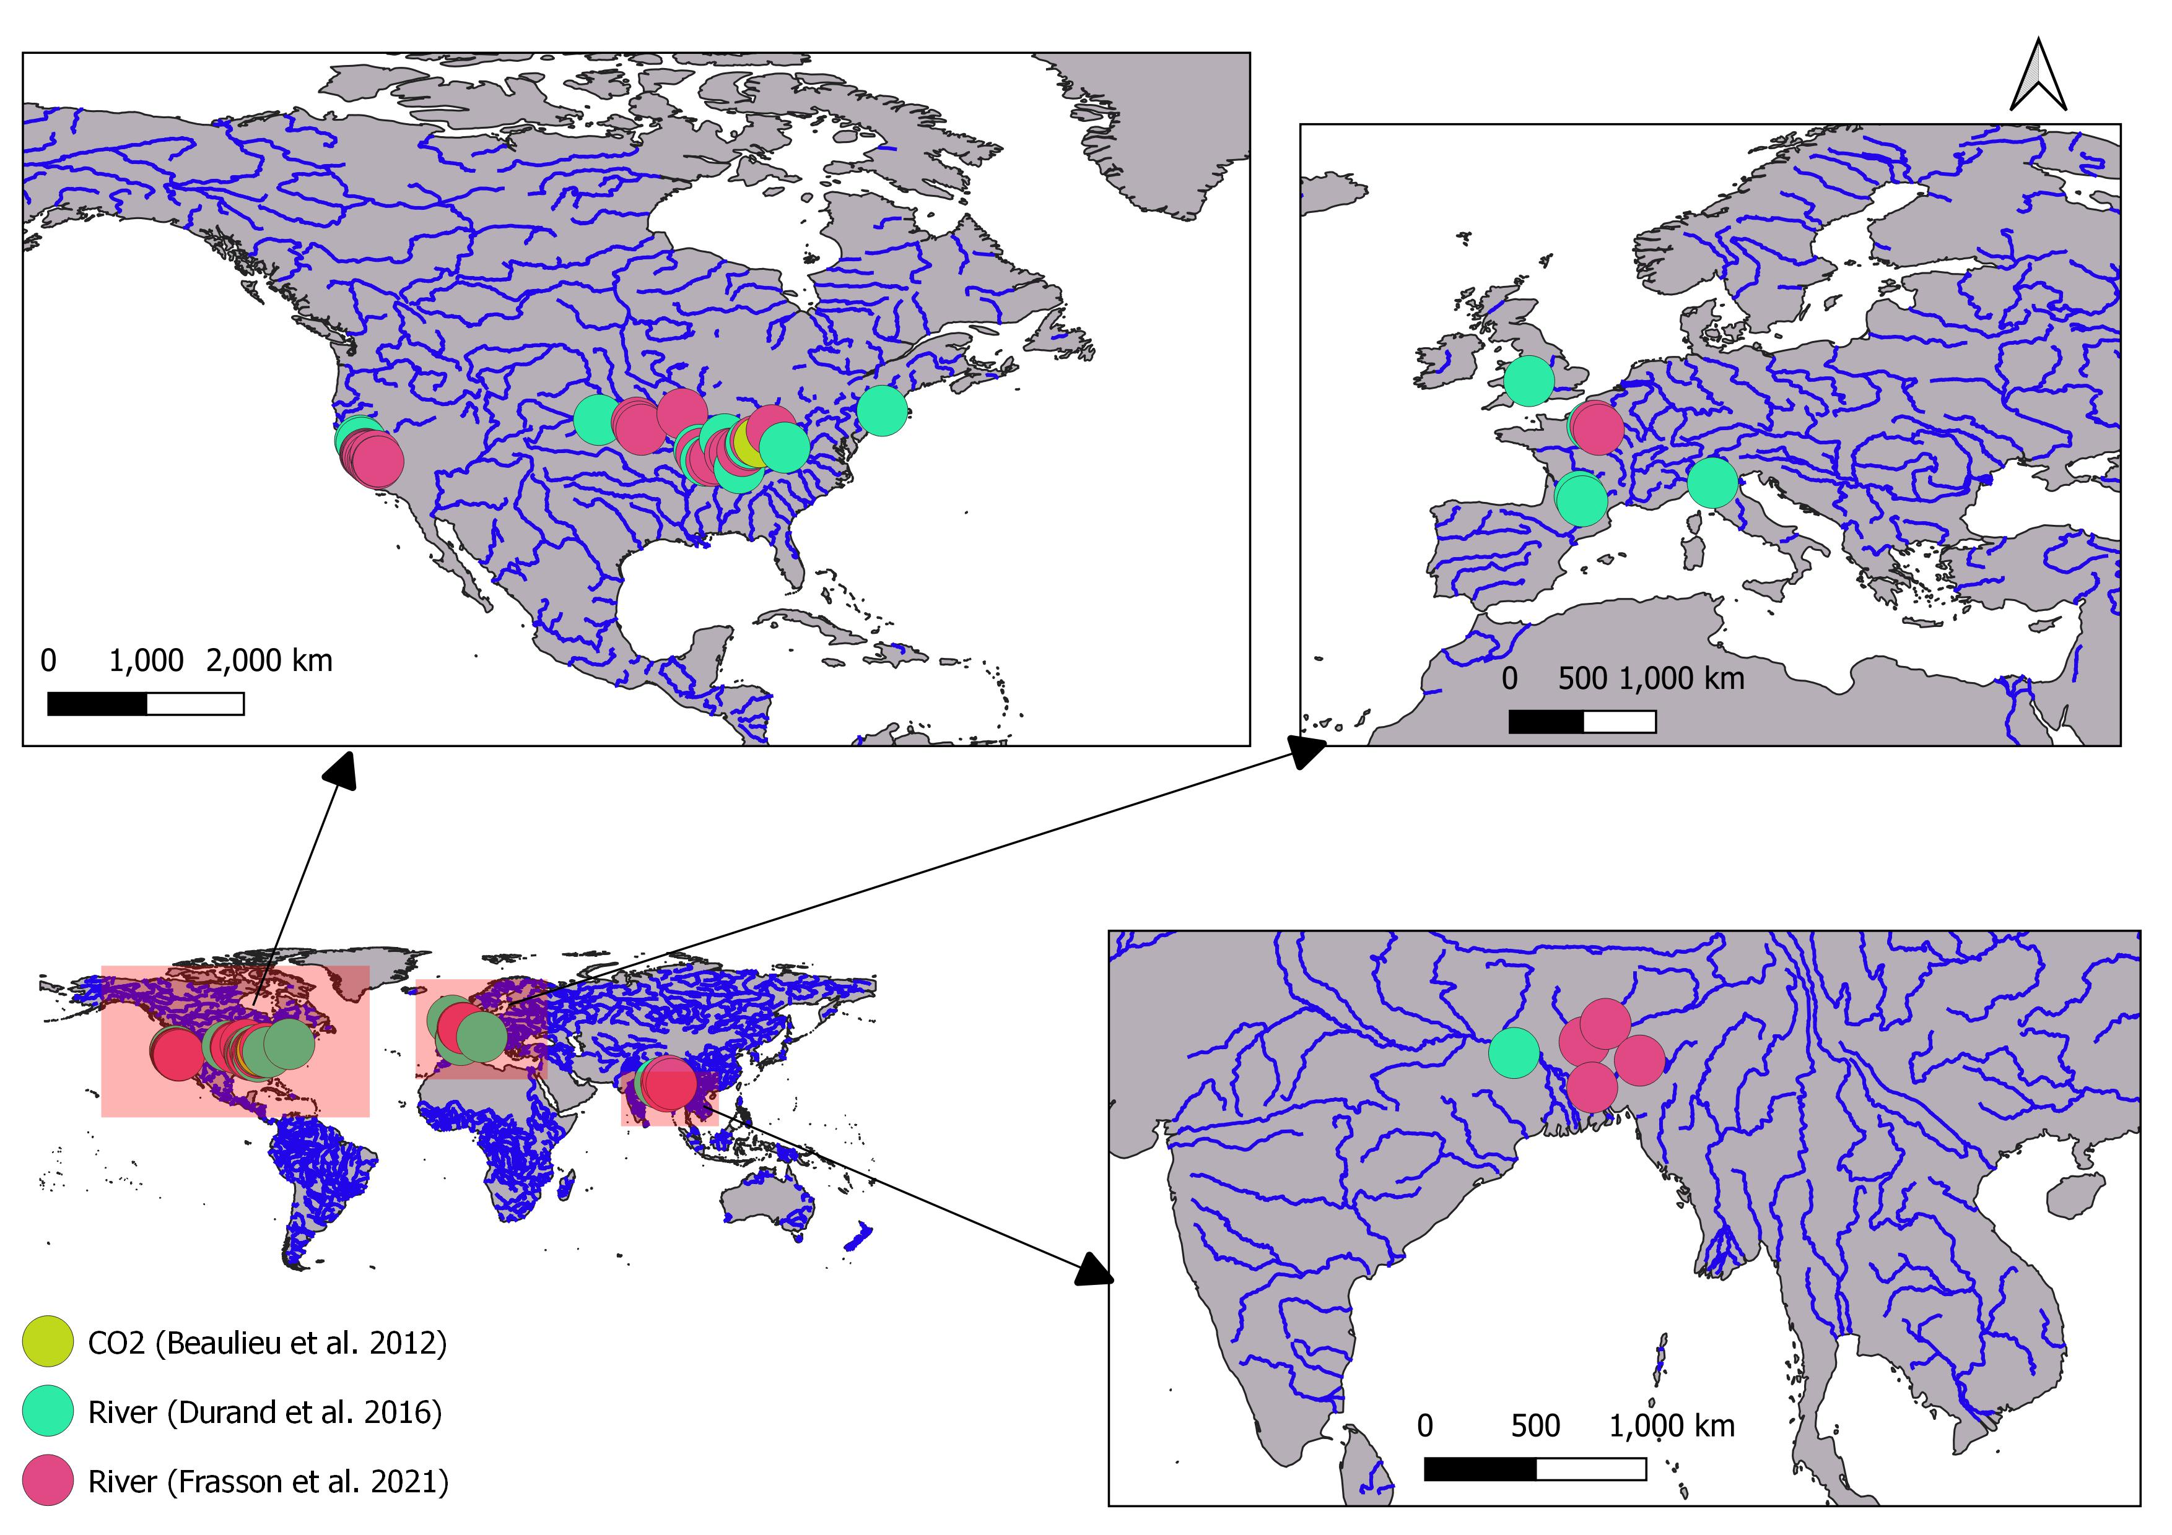

Figure 3: Map of the 47 hydraulic models and 1 timeseries of CO2 samples used in this study. Note that hydraulic model locations are approximate as some of the models are not geo-referenced. (Table S1).

To validate our remote sensing solution for $k_{600}$ (BIKER), we cannot use SWOT measurements as it has yet to launch. In the hydrology literature, it is therefore standard practice to benchmark SWOT-related algorithms on “SWOT-like” data. We use 47 SWOT-simulated rivers for validation, where these simulated rivers are simply river-reach-averaged hydraulic model outputs where the water surface heights, slopes, and widths are labelled as RS observations and are used as the sole inputs to BIKER. These were published by Frasson et al. (2021) and Durand et al. (2016) and are the two benchmarking studies that explored remote sensing of discharge (RSQ) algorithm performance for the SWOT mission. They have prepared the data to mimic SWOT by adding realistic radar errors and sampling along the satellite’s future ground track. In essence, these authors have run standard hydraulic models forced with known inflows and measured bathymetry to model the hydraulic response of these river reaches, and then sampled these model outputs according to the timing of the satellite overpass. Frasson et al. (2021) also developed a sophisticated error model that mimics the effects of the atmosphere, topography, and water surface geometry on SWOT measurements (16/47 rivers) to add realistic errors that depend on the time and place of observation. The resulting data are the most realistic synthetic SWOT river data in the literature. The approximate locations of these rivers are plotted in Figure 1.

We use 26 bi-weekly dissolved $CO_{2}$ samples collected by Beaulieu et al. (2012) at one location in the Ohio River for one calender year from 2008-2009 (Figure S1) for the $CO_{2}$ evasion and carbon efflux calculations (section 3.1.3). Note that this $CO_{2}$ data is for the Ohio River only but was applied to all rivers (which includes multiple sections of the Ohio River). Because we are exclusively interested in the relative differences between $FCO_{2}$ estimates and not the raw fluxes themselves, any $CO_{2}$ data representative of SWOT-observable rivers was deemed acceptable for this validation exercise.

### 3.2 Section 3 methods

#### 3.2.1 BIKER

BIKER, and Bayesian inference in general, starts from Bayes rule (equation 9), where $Θ$ is some set of non-remotely-sensible parameters we want to solve for (including $k_{600}$), *x* is the observed data, $f\left(x|Θ\right)$ is the sampling model where data are conditional on the parameters, and $p\left(Θ\right)$ is the joint prior distribution of the parameters. Therefore, we are interested in solving for $p\left(Θ|x\right)$, or the ‘posterior’ distribution. Note that $p\left(x\right)$ is usually computationally intractable to integrate exactly, but Bayesian inference tools require only the proportionality to be specified: $p\left(Θ|x\right)∝f\left(x|Θ\right)p\left(x\right)$. Sampling algorithms are then used to approximate the posterior distribution, as is done in BIKER.

$$p\left(Θ|x\right)=\frac{f\left(x|Θ\right)p\left(Θ\right)}{p\left(x\right)}\left(9\right)$$

The heart of BIKER is its reformulation of the $k_{600}$ model (equation 8) as a Bayesian sampling model that is conditional on the non-remotely-sensible parameters (i.e. $f\left(x|Θ\right)$ ). This is similar to the McFLI logic used in some SWOT RSQ algorithms (Gleason et al., 2017). To start, we write $k_{600}$ as a function of SWOT-observables $W$ and $S$. This algebra is carried out using equation 8, the fitted value for $β_{1}$ from Figure 3d (62.82), and Manning’s equation for mean flow velocity ($\overset{‾}{U}=\frac{1}{n}R_{h}^{2/3}S^{1/2}$). Following section 2.3, we also assume that the channel is hydraulically-wide ($R_{h}=H=\frac{A}{W}$). To leverage additional SWOT data, the wetted channel area *A* is further split into the SWOT-observable portion $dA$ and the unobservable portion $A_{0}$ following Durand et al. (2014). *dA* is readily approximated using SWOT measurements if assuming a rectangular river channel ($dA≈δH_{e}*W$), which is again generally valid in a hydraulically-wide channel.

All of this algebra simplifies to equation 10, after accounting for time-varying *t* terms and space-varying *i* terms within the reach. Conveniently, both $k_{600}$ is measured (and predicted by equation 8) at the reach-scale, so we can reduce it to a reach-averaged, time-varying quantity. This lowers the number of parameters BIKER must infer and makes the problem better constrained.

$$\begin{matrix}k_{{600}_{t}}=62.82g^{7/16}S_{it}^{9/16}{\frac{1}{n_{i}}}^{1/4}{\left(\frac{A_{0_{i}}+dA_{it}}{W_{it}}\right)}^{35/48}\end{matrix}\left(10\right)$$

Next, equation 10 is written as a Bayesian sampling model, in which all of the SWOT observations are sampled from the unknown model parameters ($A_{0_{i}}$, $k_{{600}_{t}}$, and $n_{i}$). This is equation 11 after describing them as log-normal distributions. $σ_{k_{600}}^{2}$ refers to the total uncertainty implicit in equation 10. This uncertainty is due to parameter uncertainty from equation 8, Manning’s equation, and the rectangular channel assumption.

$$\left[log\left(62.82\right)+\frac{7}{16}log\left(g\right)+\frac{9}{16}log\left(S_{i,t}\right)−\frac{35}{48}log\left(W_{i,t}\right)\right]∼normal\left(\left[log\left(k_{{600}_{t}}\right)+\frac{1}{4}log\left(n_{i}\right)−\frac{35}{48}log\left(A_{0_{i}}+dA_{i,t}\right)\right],σ_{k_{600}}^{2}\right)\left(11\right)$$

Equations 9 and 11 also necessitate that we specify prior distributions for the parameters $A_{0_{i}}$, $k_{{600}_{t}}$, and $n_{i}$. Prior distributions, described by their hyperparameters, formalize the a priori estimates (and uncertainties) for the non-remotely-sensed terms. More intuitively, BIKER priors represent our ‘prior river knowledge’ of what $A_{0_{i}}$, $k_{{600}_{t}}$, and $n_{i}$ probably are for some river since they cannot be directly remotely sensed, but educated guesses can be made using the SWOT data available to us. This is equivalent to the ‘empirical Bayes method’. Our goal in prior specification was to rely on absolutely no in situ information such that we could run this method on any river on Earth solely using SWOT observations. In theory, more informed priors via various a priori information about a specific river would improve BIKER performance, but here we chose to test only the fully generalized algorithm. Therefore, the validation presented here is a ‘worst-case scenario’, wherein BIKER performance will improve with better prior information on the river. In that context, we used a variation of the prior specification method developed by Brinkerhoff et al. (2020), who developed geomorphic ‘river types’ with distinct prior hyperparameter sets for $A_{0_{i}}$ and $n_{i}$. These hyperparameters are assigned to a river solely using SWOT data *W* and *S*, therefore meeting our needs for complete global implementability. Hyperparameter assignment for $k_{{600}_{t}}$ was developed similarly (all hyperparameter specifications are elaborated on in Texts S3 and S4).

With the sampling model defined ( $f\left(x|Θ\right)$ = equation 11) and hyperparameters $p(x$) described (Texts S3 and S4), a joint posterior distribution conditional on the SWOT observations ($p\left(Θ|x\right)∝f\left(x|Θ\right)p\left(x\right)$) is specified. To approximate this distribution, we use a Markov Chain Monte Carlo (MCMC) algorithm implemented using the Stan probabilistic programming language. Specifically, Stan uses a Hamiltonian Monte Carlo sampler which reduces computation time relative to other sampling algorithms (Hagemann et al., 2017).

#### 3.2.2 BIKER validation

We validate BIKER on 47 SWOT-simulated rivers (section 3.1) using daily observed hydraulics. We also re-validate BIKER on the 16 rivers with the SWOT error model which corrupts the SWOT measurements (widths, heights, and slopes).

We do not have observed $k_{{600}_{t}}$ data for these rivers and, to our knowledge, no field dataset of $k_{600}$ exists in the type of temporal and spatial frequency that SWOT (and therefore the BIKER algorithm) provides. Thus, we take the model outlined in equation 7 and Figure 3d and use that to calculate the observed $k_{{600}_{t}}$ that BIKER is validated against (equation 12). Here, reach-averaged flow velocity is directly calculated as discharge divided by channel area. This directly explores BIKER’s ability to infer observed $A_{0_{i}}$, $k_{{600}_{t}}$, and $n_{i}$ simultaneously from $W_{i,t}$ and $H_{i,t}$ alone and was deemed acceptable given that the $k_{600}$ model (equation 7) has already been successfully validated in Figure 3d.

$$k_{{600}_{obs}}=62.82{\left(gS\right)}^{7/16}{\overset{‾}{U}}^{1/4}H^{9/16}\left(12\right)$$

It also means that, for a fair validation scheme, the parameter specification for $σ_{k_{600}}^{2}$ in equation 11 should not include the uncertainty from equation 8. So for this validation only, $σ_{k_{600}}^{2}$ is set to 0.30 (natural-log space) to reflect uncertainty from Manning’s equation and assuming a rectangular channel (Text S4). However, if BIKER is run on real SWOT observations after the satellite launches, $σ_{k_{600}}^{2}$ should reflect the total uncertainty, which is described in Text S4.

With the setup described by equations 11 and 12, validation is performed using the BIKER posterior means. Because we are most interested in BIKER’s ability to correctly infer temporal dynamics in $k_{600}$, and each river’s priors are described specifically for that river, we validate by river. These metrics are defined in Table S2 and consist of the correlation coefficient *r* to quantify accuracy of BIKER’s temporal dynamics, the root mean square error normalized by the observed mean (NRMSE) and prediction bias normalized by the observed mean (rBIAS) to assess bias, and the Kling-Gupta Efficiency (KGE). KGE is frequently used to assess streamflow prediction and simultaneously assesses accuracy in both bias and dynamics. While a value greater than -0.41 means the model outperforms a uniform prediction of the mean (Knoben et al., 2019), generally KGE scores are interpreted as being meaningful in ungauged settings if > 0.

#### 3.2.3 Carbon efflux validation

It is one thing to accurately model the temporal dynamics of $k_{600}$, but researchers are often most interested in the actual gas fluxes from rivers and ultimately the carbon emitted from river to atmosphere. Therefore, we also explore BIKER’s ability to reproduce $FCO_{2}$ (equation 1) and the bulk carbon efflux from these 47 rivers. To do this, we pair the 26 biweekly $CO_{2}$ and water temperature samples from Beaulieu et al. (2012) (section 2, figure S1) with every 14th set of daily SWOT observations (as the $CO_{2}$ data is bi-weekly). Conveniently, this is very close to the nominal average sampling resolution for SWOT (11 days). Not all of the SWOT rivers have observations for a full year, and when simulation dates are not available they are assumed to start on January 1st. We then calculate $FCO_{2}$ using equation 1 and assuming atmospheric $CO_{2_{air}}$ is 390 uatm. Equation 13 is used to obtain a temperature and $CO_{2}$ specific gas exchange velocity from BIKER’s output, where the Schmidt number *Sc* was estimated following Raymond et al. (2012). We then estimate median and mean bulk carbon effluxes by multiplying the median or mean $FCO_{2}$ value across all rivers and timesteps (in Tg-C/yr) by the total average surface area of all 47 rivers.

$$k_{CO2,temp}=k_{600}*{\left(Sc/600\right)}^{−1/2}\left(13\right)$$

Finally, we also compare BIKER’s outputs with established in situ methods, whose specific details and parameters are provided in Table S3. Because streamflow measurements and models are vastly more frequent than measurements of river channel geometry, these in situ models are used to predict reach-averaged flow depth and flow velocity as functions of streamflow. Their outputs are in turn used to estimate *k* in upscaling workflows. Therefore, they rely on in situ streamflow records or high-quality streamflow routing outputs (unlike BIKER, which only requires a river be SWOT-observable). This allows us to assess whether BIKER’s estimates (wholly ungauged) are comparable to gauged methods (all three HG models). Of the three models tested here, one is trained on the Brinkerhoff et al. (2019) dataset, and two are previously published models (Raymond et al., 2012; Raymond et al., 2013).

### 3.3 Section 3 results

#### 3.3.1 BIKER

Figure 4 plots all 47 timeseries plots of predicted and observed $k_{600}$, again assuming no SWOT measurement error. Note that the y axis is normalized by maximum observed values to compare rivers. In general, temporal dynamics of $k_{600}$ are reproduced quite well by BIKER, however there is often positive bias in the estimates (e.g. Olentangy River). Some rivers are predicted nearly perfectly (e.g. Brahmaputra, Ohio Section 3, Wabash) while others perform more poorly (e.g. San Joaquin, Stanislaus), though again much of this error stems from errors in predicting the magnitude of $k_{600}$ rather than the temporal dynamics. Rivers where the temporal dynamics are more poorly inferred tend to have shorter timeseries (e.g. Merced River, Tuolumne River). Next, we explicitly quantify each rivers’ performance.

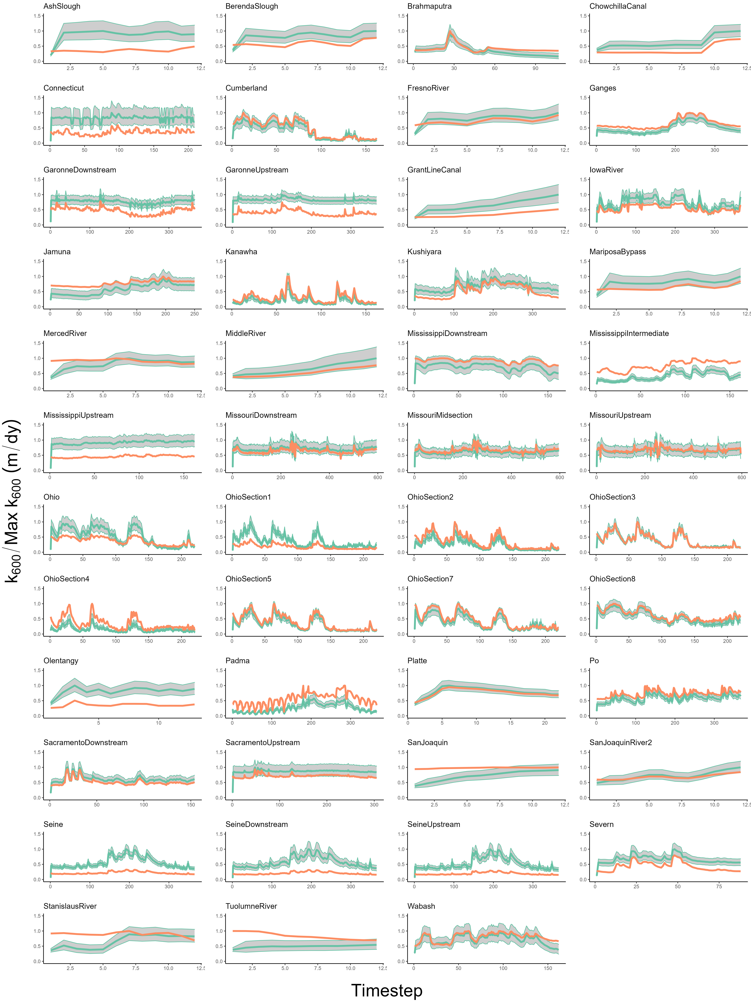

Figure 4. River timeseries plots of $k_{600}$. Orange is calculated via observed hydraulics, while green is BIKER. The green ribbon indicates the 95% CIs for the predicted values. Y axis is normalized by maximum observed values to compare visually.

We calculate performance metrics following section 3.2.2 and Table S2. These are presented in Figure 5a, which plots validation metrics calculated for each river with and without SWOT measurement error (green and purple boxplots, respectively). SWOT measurement errors negligibly influence BIKER’s performance across all four error metrics (Figure 5a), though caution should be used in over-interpreting boxplots with a sample size of only 16. Given Figure 5a, we deem that SWOT measurement error does not exert a significant influence on BIKER and so the results presented for the rest of the manuscript assume no measurement error in order to use all 47 rivers.

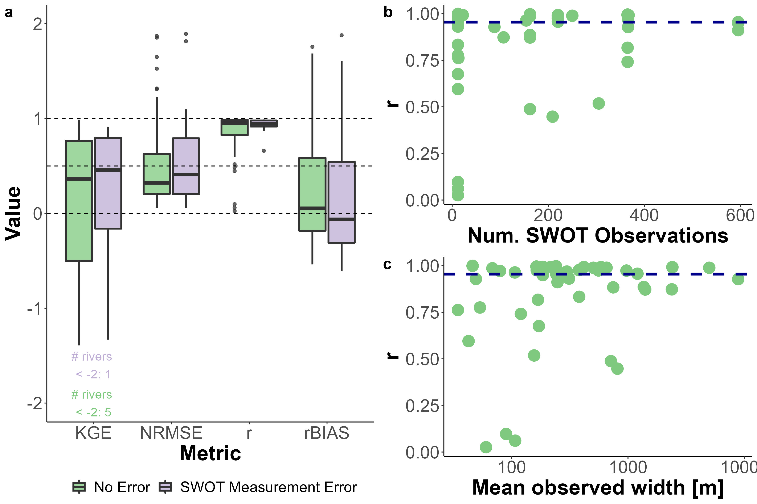

Figure 5. a: Performance metrics by river. See Table S2 for metric definitions. b: *r* versus the number of SWOT observations used in the Bayesian inversion. c) *r* versus the mean river width. As expected, performance improves with more data. Dashed lines denote scores of 0, 0.50, and 1. CIs.

Median river-specific $KGE$ is 0.36 and median river-specific *r* is 0.95. This indicates very strong inference of each river’s temporal $k_{600}$ dynamics. These scores are excellent given that absolutely no in situ information is being used to predict $k_{600}$. NRMSE has a median score of 0.32, which is reasonable for a completely ungauged method. These are comparable to the best NRMSE scores achieved by recent versions of the SWOT RSQ algorithms (Frasson et al., 2021). Median rBIAS is 0.05, which is again excellent. However, the shape of the rBIAS boxplot in Figure 3a highlights a large portion of rivers which have a positive bias (Figure 4 also confirms this). Taken in aggregate, Figures 4-5 indicate that BIKER is quite good at capturing temporal dynamics in $k_{600}$, however there is often positive bias in its estimates.

Figure 5b highlights one benefit of using Bayesian inference to estimate $k_{600}$: because the posterior is conditional on the SWOT observations, performance should improve with more data. Figure 6b plots by-river *r* scores versus the number of SWOT observations. While performance does not directly increase from having more data, very poor performances disappear as the amount of available data increases. The vast majority of the extremely poorly performing rivers are limited to those with only 12 days of SWOT observations. This bodes well for future SWOT implementation, as SWOT has a nominal life-cycle of three years. A similar relationship also exists between mean observed river width and *r* (Figure 5c), where wider rivers have better BIKER performance. However, it is impossible to say whether this is a genuine trend or an artifact of the specific rivers being tested, where the larger rivers often have longer timeseries.

Given the promising results *r* results in Figure 5a, we further explored BIKER’s ability to predict temporal trends in $k_{600}$. Figure 6a plots the regression lines between BIKER $k_{600}$ and observed $k_{600}$ for each river, making clear that some rivers have notable bias (regression lines sitting above and below the 1:1 dashed blue line).However regardless of coefficient error, nearly all rivers scale at a slope of approximately 1 (dashed blue line), indicating that temporal trends are strongly captured. This is explicitly confirmed in Figure 6b, where we plot a histogram of the slopes of Figure 6a’s regression lines, showing that vast majority of by-river regression slopes approximate 1 (median slope: 1.05).

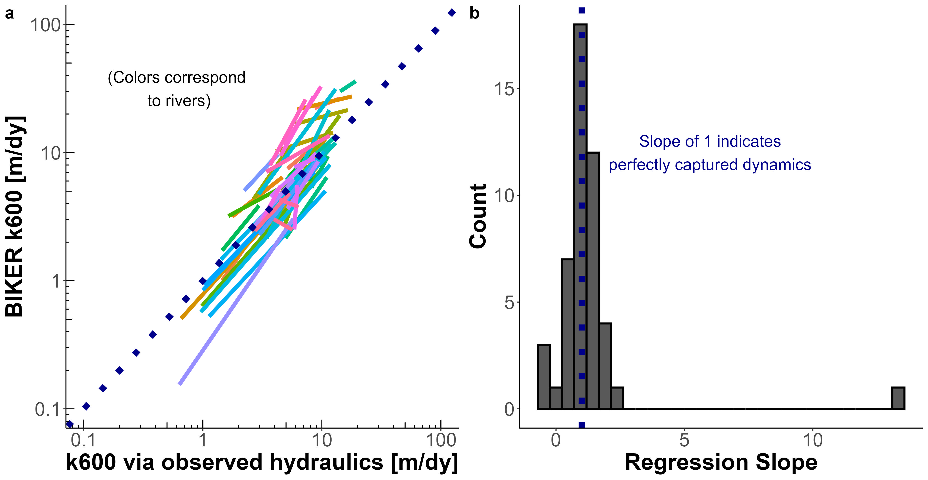

Figure 6: a: Temporal scaling of BIKER predictions for the 47 rivers, compared to observed k600 and plotted as regression lines to aid in visualization. b: Histogram of the slopes of these by-river regression lines. Slopes equal 1 indicate perfect predicition of the temporal trends in daily k600 (regardless of bias in the estimates).

#### 3.3.2 Carbon efflux

Next, we compare BIKER’s estimates of carbon fluxes against established in situ techniques. It is important to remember that only BIKER is completely globally implementable, while the other three models presented necessarily rely on having a streamflow record readily available. Therefore, the HG methods reflect their ‘best-case scenarios’ while BIKER reflects its worst case scenario, where priors are set entirely from SWOT observations and are generally the least informative they will ever be.

Figure 7a evaluates the $FCO_{2}$ estimates using the same 4 error metrics as Figure 6a. BIKER, the sole remote technique, is in red while the three in situ techniques are plotted as different shades of purple. We see that BIKER performs slightly worse than all three in situ methods across all metrics except *r*, where it performs similarly to the ‘Raymond 2013’ model. **NEED ACTUAL NUMBERS HERE**. However, across all 47 rivers BIKER has the least overall bias in its estimates (**add number here**). In summary, BIKER performs slightly worse than the in situ tools, as expected. However, the drop in performance is not substantial and is promising given that the in situ models represent their best case scenarios (perfect in situ discharge records) while BIKER represents its worst-case scenario (relatively uninformed priors).

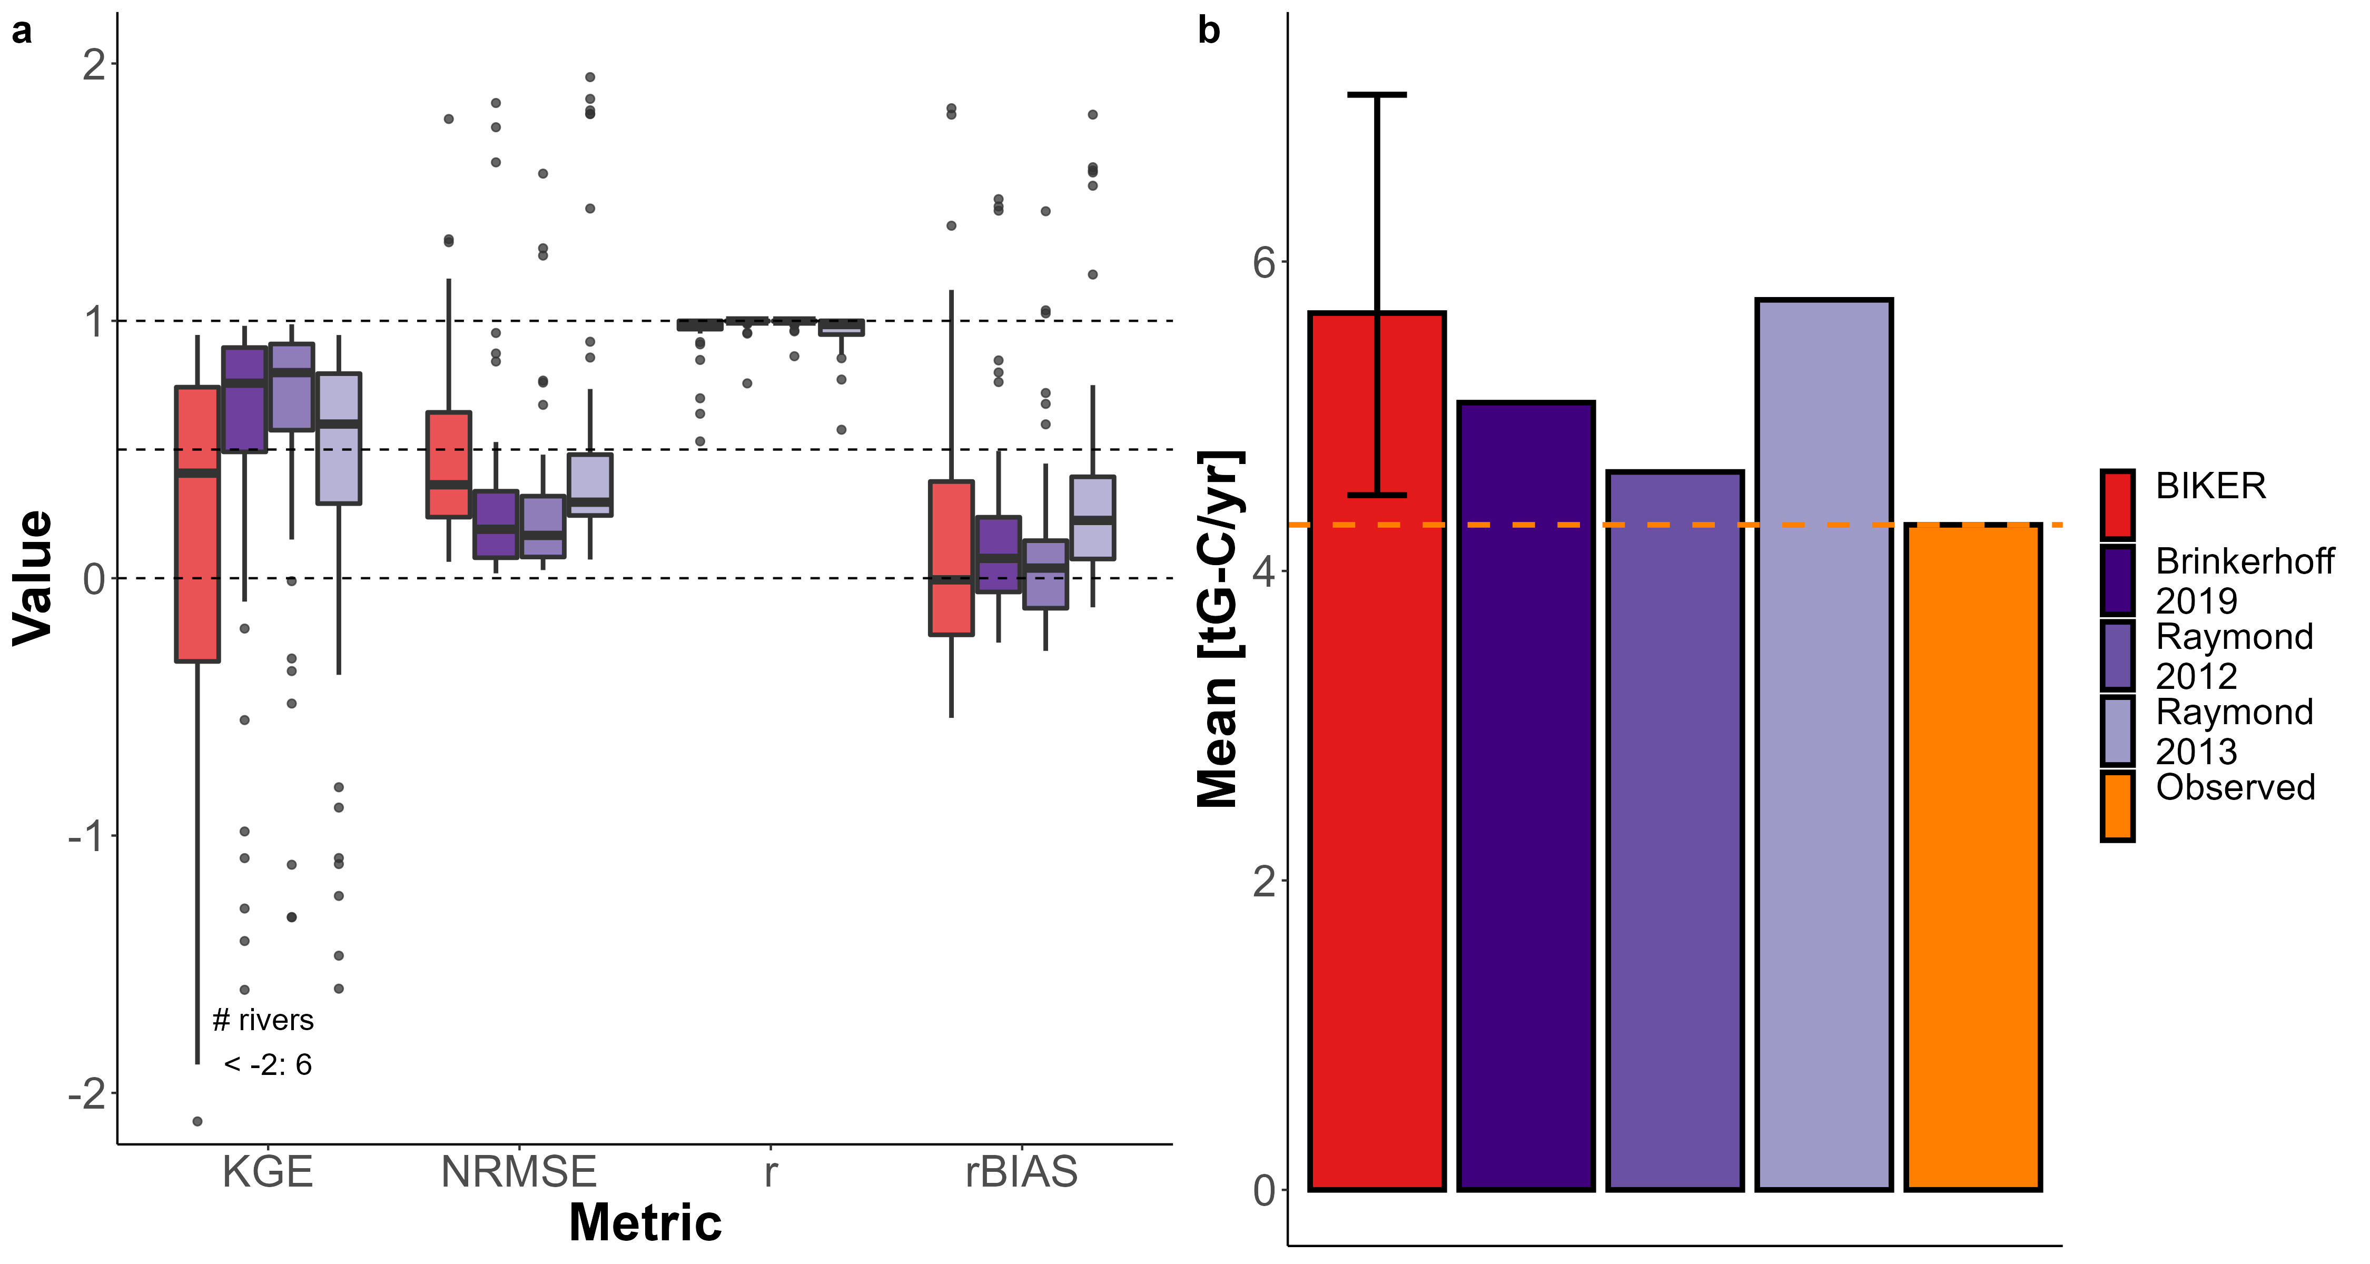

Figure 7: a) FCO2 validation for BIKER and the three in situ HG models. b) Average carbon emissions via CO2 evasion across all rivers and timesteps, accounting for surface area. Completely remotely-sensed methods are colored in red, in situ methods in purple, and the observed values in orange.

Figures 7b compares the average carbon emissions rate (via $F_{CO_{2}}$) from the 47 rivers using BIKER posterior means and the three streamgauge-based HG models. All estimates are positively biased, with BIKER (5.67 gG-C/yr) and ‘Raymond 2013’ (5.75 gG-C/yr) the most overestimated relative to the observed flux (4.3 gG-C/yr). *MORE* Thus, despite BIKER using absolutely no streamgauge or other in situ data like the other 3 methods do, it provides a reasonable upscaling estimate of the bulk carbon efflux across many rivers (Figure 6c).

## 4 Discussion

### 4.1 Gas exchange in hydraulically-wide rivers

Field studies of gas exchange in wide rivers have suggested that their *k* properties behave differently than in steeper and smaller rivers (Alin et al., 2011; Beaulieu et al., 2012; Ulseth et al., 2019; Wang et al., 2021). While much work has focused on the small-stream side of the stream-to-river continuum, comparitvely less work has been done in large systems. Here, we focus on the ‘smooth-channel’ end of the continuum, using a model for gas exchange that scales *k* by both the turbulent dissipation rate and the Shear Reynold’s number specifically adapted for ‘hydraulically-wide’ rivers. This is empirically validated in Figure 3d. Scaling *k* this way (via both the turbulent dissipation rate and the shear Reynold’s number) is frequently done in oceanic gas exchange studies [*EXAMPLES*] and has been occasionally explored in open-channel flows (Moog & Jirka, 1999a; Wang et al., 2021). However to our knowledge, Moog & Jirka (1999a)’s specific model has never been empirically validated in rivers. Figure 3d provides this empirical verification. Future tests should be performed to explore the model’s feasibility in smaller streams and/or other aquatic environments where turbulence is also generally low. Future tests should also explore other shear Reynold’s scaling relations for gas exchange in rivers.

Given the algebraic structure of the various dissipation and gas exchange models tested (Table 1), the performance differences observed in Figure 3 are largely due to the exponents applied to the river hydraulic terms (which are described in the subplot x axis labels). While the use of the form-drag dissipation model includes a mean flow velocity term and improves performance, the primary difference between the respective small-eddy and chainsaw equations is the exponents. Intuitively, this exponent discrepancy indicates that in hydraulically-wide rivers where turbulence is relatively low, large-scale eddies exert a noteworthy influence on surface dissipation rates and that the small-eddy model is not sufficient.

Finally, we are not accounting for gas exchange facilitated by air-side wind, which exerts a significant influence on lake and ocean gas exchange. Similarly, none of the existing hydraulics-driven gas exchange models do either, assuming that the rivers are sheltered enough that wind is of less concern. We suspect that our model will be less representative in extremely wide rivers where wind becomes a driving factor of gas exchange rates (Beaulieu et al., 2012). In that vein, BIKER’s outputs can be interpreted as the ‘gas exchange velocity in low-wind conditions’. That said, BIKER’s flexible implementation is a good start towards eventually coupling hydraulics-driven gas exchange with wind-driven gas exchange. Such a model would likely take a form similar to the conceptual model proposed by Wang et al. (2021) that proposes calculating both a wind-driven *k* and a hydraulics-driven *k* and then weighting each term via parameters. In the case of BIKER, this would necessitate additional parameters that would need to be known a priori for specific rivers. This is left to future work.

### 4.2 Towards remote sensing of global spatiotemporal dynamics of *k* in large rivers

To date, the studies exploring the spatiotemporal dynamics of riverine gas exchange have arguably been held back by a lack of data. A few studies have investigated these dynamics, but they have been limited to individual rivers and/or limited field seasons (Hall et al., 2012; Sand-Jensen & Staehr, 2012). For example, Wallin et al. (2011) performed a preliminary analysis in northern Sweden relating cross-section specific temporal variability in gas exchange with channel slope, but they were limited to a mean of only 8 measurements per river in a single watershed.

Therefore, estimating *k* from SWOT data is an attractive option, at least for exploring its spatiotemporal dynamics at fine temporal resolution and at the global-scale. Section 5 shows that BIKER successfully infers the temporal dynamics of $k_{600}$ using simulated SWOT data over a wide range of rivers and with implicit measurement errors accounted for (Figures 4-6). This strong result bodes well for BIKER’s eventual implementation on real SWOT observations, as does BIKER’s improved performance with longer timeseries (Figure 6b). The nominal three-year SWOT campaign will provide hundreds of observations for most rivers, suggesting even better BIKER inversions than those presented here. All of this suggests that near-daily estimation of the spatiotemporal trends in global riverine gas exchange will be possible once SWOT launches.

With that said, Figures 4-7 highlight a substantial range of algorithm performances across rivers. These differences in performance are likely due to the representativeness of the priors used for that river. This all makes sense as Section 2 has effectively reduced $k_{600}$ to a function of hydraulics that are nearly all directly measurable by SWOT. Any resulting bias in BIKER’s predictions is therefore attributable to bias in the priors used for the non-remotely sensed terms (equations 10-11). For SWOT discharge algorithms, authors have repeatedly shown that the ‘quality’ of prior hyperparameters plays a large role in the success of discharge inversions (Andreadis et al., 2020; Brinkerhoff et al., 2020; Frasson et al., 2021; Tuozzolo et al., 2019) and our results here further corroborate this finding. It should be stressed that a substantial portion of rivers from (Frasson et al., 2021) are canal-shaped in nature with different hydraulic properties than a natural river channel. Nearly universally, these rivers underperformed (Figure 5), however it is impossible to isolate whether that is due to channel geomorphology or the fact that these canals also usually had short timeseries (around 12 days).

### 4.3 Towards remotely sensing riverine carbon emissions using SWOT

Figure 7 confirms that BIKER is quite successful, without any in situ information aside from a $CO_{2}$ logger, at predicting both $FCO_{2}$ (Figure 6a) and 2) the bulk carbon efflux (Figure 7b-7c). This encouraging result has two main implications for future work coupling remote sensing via SWOT with in situ data. First, it confirms that we can couple BIKER and SWOT with in situ gas concentration loggers to produce reasonable $FCO_{2}$ estimates at novel temporal resolutions in SWOT-observable rivers. This is particularly useful given recent advances in in situ gas concentration loggers (e.g. Aho et al., 2021) but no such similar advances in modeling *k* at equivalent temporal resolutions. BIKER can likely also be ran at the field scale using arrays of pressure transducers to estimate water surface slope (rather than using satellite-based altimeters like SWOT) following recent similar work for estimating streamflow (Harlan et al., 2021).

Secondly, it is important to again stress that unlike BIKER, the HG models in Figure 7 rely on an in situ streamgauge. This means that Figure 7 represents the best performance that those models could ever have, while BIKER represents the worse performance it could ever have. If the HG models are ran using modeled discharge, their accuracy would necessarily decrease. Thus, these results suggest that BIKER will be useful in not only assessing gas exchange velocities, but also in providing additional measurements to upscaling workflows that rely on modeled streamflow [e.g. **Liu etal in review**].

## 5 Conclusions

Gas exchange from aquatic systems has been studied for nearly a century and dozens of predictive equations have been developed to obtain *k* values from easily measured hydraulic properties rather than via direct measurement. Likewise, equation 3 has been repeatedly verified across many non-fluvial environments. However. despite renewed interest in fluvial gas exchange in the last decade or so, there are considerable uncertainties in how fluvial *k* varies with respect to time. This is generally due to a lack of direct measurements of $k_{600}$. In this paper, we propose that the soon-to-launch SWOT satellite will provide enough hydraulic measurements to analyse the temporal dynamics of $k_{600}$ using SWOT measurements, and therefore allow for a global-scale analysis of spatiotemporal trends in *k* once SWOT launches.

In preparation for SWOT’s launch, we develop the BIKER algorithm to infer $k_{600}$ using absolutely no on-the-ground information. Validating on simulated SWOT rivers, we show show strong recovery of rivers’ temporal $k_{600}$ dynamics. We also pair BIKER with an in situ $CO_{2}$ logger and show strong performance in reproducing $CO_{2}$ evasion fluxes and bulk carbon efflux from the rivers’ combined surfaces. These strong results functionally open the door for global-scale, near daily estimates of fluvial gas exchange velocity once SWOT launches in 2022. This unprecedented amount of data should allow for significant insights into the temporal dynamics of fluvial gas exchange in large rivers around the world.

## 6 Acknowledgements

C.B. Brinkerhoff was funded on **FINESST**. The version of BIKER used in this study is available at **citable code here**. BIKER remains in active development and is available at <https://github.com/craigbrinkerhoff/BIKER>. All code to build and generate results, figures, and the manuscript is available at <https://github.com/craigbrinkerhoff/RSK600>. We thank Renato Frasson, Michael Durand, Amber Ulseth, and Jake Beaulieu for generously making their data available for this study. We also thank the entire SWOT discharge working group for their decade-plus body of work which inspired this study.

## 7 Apendix A

*Table A1: Variable description and notation for this study. ADD THE BAYES PARAMETERS YET*

| **Notation** | **Description** | **Calculation (if not directly measured)** | **Units** |
| --- | --- | --- | --- |
| $A$ | Channel cross-sectional area | NA | $\left[L^{2}\right]$ |
| $A_{0}$ | Non-SWOT-observable cross-sectional area | NA | $\left[L^{2}\right]$ |
| $α$ | Statistical parameter for equation 5 scaling relation | NA | $\frac{m^{1/2}s^{3/4}}{dy}$ |
| $α_{1}$ | Statistical parameter for equation 6 scaling relation | NA | $\frac{m^{1/2}s^{3/4}}{dy}$ |
| *Bulk carbon efflux* | carbon mass transport rate from river to atmosphere | NA | $\left[\frac{M}{T}\right]$ |
| $β$ | Statistical parameter for equation 7 scaling relation | NA | $\frac{m^{−1/4}s^{9/8}}{dy}$ |
| $β_{1}$ | Statistical parameter for equation 8 scaling relation | NA | $\frac{m^{1/2}s^{3/4}}{dy}$ |
| $CO_{2_{water}}$ | Water-side $CO_{2}$ concentration | NA | $\left[L\right]$ |
| $CO_{2_{air}}$ | Atmospheric-side $CO_{2}$ concentration | NA | $\left[L\right]$ |
| $dA$ | change in cross-sectional area | $δH_{e}*W$ | $\left[L\right]$ |
| $D_{m}$ | Molecular diffusion coefficient | NA | $\left[\frac{L^{2}}{T}\right]$ |
| $ϵ$ | Dissipation rate of near-surface turbulence | NA | $\left[\frac{E}{M*T}\right]$ |
| $ϵ_{S}$ | log-law-of-the-wall model for $ϵ$ | $\frac{U_{*}^{3}}{H}$ | $\left[\frac{E}{M*T}\right]$ |
| $ϵ_{D}$ | Form-drag model for $ϵ$ | $gS\overset{‾}{U}$ | $\left[\frac{E}{M*T}\right]$ |
| $FCO_{2}$ | $CO_{2}$ evasion flux from river to atmosphere | NA | $\left[\frac{M}{L^{2}T}\right]$ |
| $FCO_{2_{upscaled}}$ | Upscaling estimate of the global $CO_{2}$ evasion flux from river to atmosphere | NA | $\left[\frac{M}{L^{2}T}\right]$ |
| $g$ | gravitational acceleration | 9.8 | $\left[\frac{L}{T^{2}}\right]$ |
| $H$ | Mean flow depth | $A/W$ | $\left[L\right]$ |
| $H_{e}$ | Water surface elevation | NA | $\left[L\right]$ |
| $i$ | Cross-section discretization within river reach | NA | NA |
| $k$ | gas exchange velocity | NA | $\left[\frac{L}{T}\right]$ |
| $k_{600}$ | gas exchange velocity normalized to $Sc=600$ | ${\left(\frac{600}{Sc_{k}}\right)}^{−0.5}k$ | $\left[\frac{L}{T}\right]$ |
| $k_{{600}_{obs}}$ | “observed” gas exchange velocity normalized to $Sc=600$ | $k_{{600}_{obs}}=62.82{\left(gS\right)}^{7/16}{\overset{‾}{U}}^{1/4}H^{9/16}$ | $\left[\frac{L}{T}\right]$ |
| $n$ | Manning’s roughness coefficient | $\frac{R_{h}^{2/3}S^{1/2}}{\overset{‾}{U}}$ | $\left[\frac{T}{L^{3}}\right]$ |
| $ρ$ | Density of water | NA | $\left[\frac{M}{L^{3}}\right]$ |
| $Q$ | River discharge | NA | $\frac{L^{3}}{T}$ |
| $R_{h}$ | Hydraulic radius | $\frac{AW}{2H+W}$ | $\left[L\right]$ |
| $S$ | River slope | NA | $unitless$ |
| $Sc$ | Schmidt number | $\frac{v}{D_{m}}$ | NA |
| $σ_{k_{600}}^{2}$ | BIKER uncertainty (posterior distribution standard deviation) | NA | $\left[L/T\right]$ |
| $t$ | timestep discretization within river reach | NA | NA |
| $Θ$ | Bayesian parameter set | NA | NA |
| $\overset{‾}{U}$ | Cross-sectional average velocity | $\frac{Q}{A}$ | $\left[\frac{L}{T}\right]$ |
| $U_{*}$ | Shear velocity | $\sqrt{gSR_{h}}$ | $\left[\frac{L}{T}\right]$ |
| $μ$ | Viscosity | NA | $\left[P*T\right]$ |
| $v$ | kinematic viscosity | $\frac{μ}{ρ}$ | $\left[\frac{L^{2}}{T}\right]$ |
| $W$ | Flow width | NA | $\left[L\right]$ |
| $x$ | Bayesian data set | NA | NA |

## References

Aho, K. S., Hosen, J. D., Logozzo, L. A., McGillis, W. R., & Raymond, P. A. (2021). Highest rates of gross primary productivity maintained despite CO2 depletion in a temperate river network. *Limnology and Oceanography Letters*, *n/a*(n/a). <https://doi.org/10.1002/lol2.10195>

Alin, S. R., Rasera, M. de F. F. L., Salimon, C. I., Richey, J. E., Holtgrieve, G. W., Krusche, A. V., & Snidvongs, A. (2011). Physical controls on carbon dioxide transfer velocity and flux in low-gradient river systems and implications for regional carbon budgets. *Journal of Geophysical Research: Biogeosciences*, *116*(G1). <https://doi.org/10.1029/2010JG001398>

Andreadis, K. M., Brinkerhoff, C. B., & Gleason, C. J. (2020). Constraining the assimilation of SWOT observations with hydraulic geometry relations. *Water Resources Research*. <https://doi.org/10.1029/2019WR026611>

Appling, A. P., Hall, R. O., Yackulic, C. B., & Arroita, M. (2018). Overcoming Equifinality: Leveraging Long Time Series for Stream Metabolism Estimation. *Journal of Geophysical Research: Biogeosciences*, *123*(2), 624–645. <https://doi.org/10.1002/2017JG004140>

Beaulieu, J. J., Shuster, W. D., & Rebholz, J. A. (2012). Controls on gas transfer velocities in a large river. *Journal of Geophysical Research: Biogeosciences*, *117*(G2). <https://doi.org/10.1029/2011JG001794>

Biancamaria, S., Lettenmaier, D. P., & Pavelsky, T. M. (2016). The SWOT Mission and Its Capabilities for Land Hydrology. In A. Cazenave, N. Champollion, J. Benveniste, & J. Chen (Eds.), *Remote Sensing and Water Resources* (pp. 117–147). Cham: Springer International Publishing. <https://doi.org/10.1007/978-3-319-32449-4_6>

Borges, A. V., Darchambeau, F., Teodoru, C. R., Marwick, T. R., Tamooh, F., Geeraert, N., et al. (2015). Globally significant greenhouse-gas emissions from African inland waters. *Nature Geoscience*, *8*(8), 637–642. <https://doi.org/10.1038/ngeo2486>

Brinkerhoff, C. B., Gleason, C. J., & Ostendorf, D. W. (2019). Reconciling at-a-Station and at-Many-Stations Hydraulic Geometry Through River-Wide Geomorphology. *Geophysical Research Letters*, *46*(16), 9637–9647. <https://doi.org/10.1029/2019GL084529>

Brinkerhoff, C. B., Gleason, C. J., Feng, D., & Lin, P. (2020). Constraining Remote River Discharge Estimation Using Reach-Scale Geomorphology. *Water Resources Research*, *56*(11), e2020WR027949. <https://doi.org/10.1029/2020WR027949>

Brinkerhoff, C. B., Raymond, P. A., Maavara, T., Ishitsuka, Y., Aho, K. S., & Gleason, C. J. (2021). Lake Morphometry and River Network Controls on Evasion of Terrestrially Sourced Headwater CO2. *Geophysical Research Letters*, *48*(1), e2020GL090068. <https://doi.org/10.1029/2020GL090068>

Brisset, P., Monnier, J., Garambois, P.-A., & Roux, H. (2018). On the assimilation of altimetric data in 1D Saint river flow models. *Advances in Water Resources*, *119*, 41–59. <https://doi.org/10.1016/j.advwatres.2018.06.004>

Churchill, M. A., Elmore, H. L., & Buckingham, R. A. (1964). The Prediction of Stream Reaeration Rates. In B. A. Southgate (Ed.), *Advances in Water Pollution Research* (pp. 89–136). Pergamon. <https://doi.org/10.1016/B978-1-4832-8391-3.50015-4>

Cole, J. J., Prairie, Y. T., Caraco, N. F., McDowell, W. H., Tranvik, L. J., Striegl, R. G., et al. (2007). Plumbing the Global Carbon Cycle: Integrating Inland Waters into the Terrestrial Carbon Budget. *Ecosystems*, *10*(1), 172–185. <https://doi.org/10.1007/s10021-006-9013-8>

Crawford, J. T., Stanley, E. H., Dornblaser, M. M., & Striegl, R. G. (2017). CO2 time series patterns in contrasting headwater streams of North America. *Aquatic Sciences*, *79*(3), 473–486. <https://doi.org/10.1007/s00027-016-0511-2>

Durand, M. T., Neal, J., Rodríguez, E., Andreadis, K. M., Smith, L. C., & Yoon, Y. (2014). Estimating reach-averaged discharge for the River Severn from measurements of river water surface elevation and slope. *Journal of Hydrology*, *511*, 92–104. <https://doi.org/10.1016/j.jhydrol.2013.12.050>

Durand, M. T., Gleason, C. J., Garambois, P. A., Bjerklie, D., Smith, L. C., Roux, H., et al. (2016). An intercomparison of remote sensing river discharge estimation algorithms from measurements of river height, width, and slope. *Water Resources Research*, *52*(6), 4527–4549. <https://doi.org/10.1002/2015WR018434>

Frasson, R. P. de M., Durand, M. T., Larnier, K., Gleason, C., Andreadis, K. M., Hagemann, M., et al. (2021). Exploring the factors controlling the error characteristics of the Surface Water and Ocean Topography mission discharge estimates. *Water Resources Research*, *n/a*(n/a), e2020WR028519. <https://doi.org/10.1029/2020WR028519>

Garambois, P.-A., & Monnier, J. (2015). Inference of effective river properties from remotely sensed observations of water surface. *Advances in Water Resources*, *79*, 103–120. <https://doi.org/10.1016/j.advwatres.2015.02.007>

Garambois, P.-A., Larnier, K., Monnier, J., Finaud-Guyot, P., Verley, J., Montazem, A.-S., & Calmant, S. (2020). Variational estimation of effective channel and ungauged anabranching river discharge from multi-satellite water heights of different spatial sparsity. *Journal of Hydrology*, *581*, 124409. <https://doi.org/10.1016/j.jhydrol.2019.124409>

Gleason, C. J., Smith, L. C., & Lee, J. (2014). Retrieval of river discharge solely from satellite imagery and at-many-stations hydraulic geometry: Sensitivity to river form and optimization parameters. *Water Resources Research*, *50*(12), 9604–9619. <https://doi.org/10.1002/2014WR016109>

Gleason, C. J., Garambois, P.-A., & Durand, M. T. (2017). Tracking River Flows from Space. *Eos*. <https://doi.org/10.1029/2017EO078085>

Gruber, N., Clement, D., Carter, B. R., Feely, R. A., Heuven, S. van, Hoppema, M., et al. (2019). The oceanic sink for anthropogenic CO2 from 1994 to 2007. *Science*, *363*(6432), 1193–1199. <https://doi.org/10.1126/science.aau5153>

Hagemann, M. W., Gleason, C. J., & Durand, M. T. (2017). BAM: Bayesian AMHG-Manning Inference of Discharge Using Remotely Sensed Stream Width, Slope, and Height. *Water Resources Research*, *53*(11), 9692–9707. <https://doi.org/10.1002/2017WR021626>

Hall, R. O., & Ulseth, A. J. (2020). Gas exchange in streams and rivers. *WIREs Water*, *7*(1), e1391. <https://doi.org/10.1002/wat2.1391>

Hall, R. O., Kennedy, T. A., & Rosi-Marshall, E. J. (2012). Airwater oxygen exchange in a large whitewater river. *Limnology and Oceanography: Fluids and Environments*, *2*(1), 1–11. <https://doi.org/10.1215/21573689-1572535>

Harlan, M. E., Gleason, C. J., Altenau, E. H., Butman, D., Carter, T., Chu, V. W., et al. (2021). Discharge Estimation from Dense Arrays of Pressure Transducers. *Water Resources Research*, *n/a*(n/a), e2020WR028714. <https://doi.org/10.1029/2020WR028714>

Horgby, Å., Segatto, P. L., Bertuzzo, E., Lauerwald, R., Lehner, B., Ulseth, A. J., et al. (2019). Unexpected large evasion fluxes of carbon dioxide from turbulent streams draining the world’s mountains. *Nature Communications*, *10*(1). <https://doi.org/10.1038/s41467-019-12905-z>

Katul, G., Mammarella, I., Grönholm, T., & Vesala, T. (2018). A Structure Function Model Recovers the Many Formulations for Air-Water Gas Transfer Velocity. *Water Resources Research*, *54*(9), 5905–5920. <https://doi.org/10.1029/2018WR022731>

Knoben, W. J. M., Freer, J. E., & Woods, R. A. (2019). Technical note: Inherent benchmark or not? Comparing Nash and Kling efficiency scores. *Hydrology and Earth System Sciences*, *23*(10), 4323–4331. <https://doi.org/10.5194/hess-23-4323-2019>

Lamont, J. C., & Scott, D. S. (1970). An Eddy Cell Model of Mass Transfer into the Surface of a Turbulent Liquid. *AIChE Journal*, *16*(4), 513–519.

Larnier, K., Monnier, J., Garambois, P.-A., & Verley, J. (2020). River discharge and bathymetry estimation from SWOT altimetry measurements. *Inverse Problems in Science and Engineering*, *0*(0), 1–31. <https://doi.org/10.1080/17415977.2020.1803858>

Lauerwald, R., Laruelle, G. G., Hartmann, J., Ciais, P., & Regnier, P. A. G. (2015). Spatial patterns in CO2 evasion from the global river network. *Global Biogeochemical Cycles*, *29*(5), 534–554. <https://doi.org/10.1002/2014GB004941>

Leopold, L. B., & Maddock, T. (1953). *The Hydraulic Geometry of Stream Channels and Some Physiographic Implications*. U.S. Government Printing Office.

Lorke, A., & Peeters, F. (2006). Toward a Unified Scaling Relation for Interfacial Fluxes. *Journal of Physical Oceanography*, *36*(5), 955–961. <https://doi.org/10.1175/JPO2903.1>

Moog, D. B., & Jirka, G. H. (1999a). Air-Water Gas Transfer in Uniform Channel Flow. *Journal of Hydraulic Engineering*, *125*(1), 3–10. <https://doi.org/10.1061/(ASCE)0733-9429(1999)125:1(3)>

Moog, D. B., & Jirka, G. H. (1999b). Stream Reaeration in Nonuniform Flow: Macroroughness Enhancement. *Journal of Hydraulic Engineering*, *125*(1), 6.

Nezu, I., & Nakagawa, H. (1993). *Turbulence in Open Channel Flows*. A.A. Balkema.

Oubanas, H., Gejadze, I., Malaterre, P.-O., Durand, M., Wei, R., Frasson, R. P. M., & Domeneghetti, A. (2018). Discharge Estimation in Ungauged Basins Through Variational Data Assimilation: The Potential of the SWOT Mission. *Water Resources Research*, *54*(3), 2405–2423. <https://doi.org/10.1002/2017WR021735>

Owens, M., Edwards, R. W., & Gibbs, J. W. (1964). Some reaeration studies in streams. *Inter. J. Air Water Poll.*, *8*, 469–486.

Pan, Y., Birdsey, R. A., Fang, J., Houghton, R., Kauppi, P. E., Kurz, W. A., et al. (2011). A Large and Persistent Carbon Sink in the World’s Forests. *Science*, *333*(6045), 988–993. <https://doi.org/10.1126/science.1201609>

Peter, H., Singer, G. A., Preiler, C., Chifflard, P., Steniczka, G., & Battin, T. J. (2014). Scales and drivers of temporal pCO2 dynamics in an Alpine stream. *Journal of Geophysical Research: Biogeosciences*, *119*(6), 1078–1091. <https://doi.org/10.1002/2013JG002552>

Ran, L., Lu, X. X., & Liu, S. (2017). Dynamics of riverine CO2 in the Yangtze River fluvial network and their implications for carbon evasion. *Biogeosciences*, *14*, 2183–2198.

Raymond, P. A., Bauer, J. E., & Cole, J. J. (2000). Atmospheric CO2 evasion, dissolved inorganic carbon production, and net heterotrophy in the York River estuary. *Limnology and Oceanography*, *45*(8), 1707–1717. <https://doi.org/10.4319/lo.2000.45.8.1707>

Raymond, P. A., Zappa, C. J., Butman, D., Bott, T. L., Potter, J., Mulholland, P., et al. (2012). Scaling the gas transfer velocity and hydraulic geometry in streams and small rivers. *Limnology and Oceanography*, 41–53. <https://doi.org/10.1215/21573689-1597669@10.1002/(ISSN)1939-5590.MethaneVI>

Raymond, P. A., Hartmann, J., Lauerwald, R., Sobek, S., McDonald, C., Hoover, M., et al. (2013). Global carbon dioxide emissions from inland waters. *Nature*, *503*(7476), 355–359. <https://doi.org/10.1038/nature12760>

Rocher-Ros, G., Sponseller, R. A., Lidberg, W., Mörth, C.-M., & Giesler, R. (2019). Landscape process domains drive patterns of CO2 evasion from river networks. *Limnology and Oceanography Letters*, *4*(4), 87–95. <https://doi.org/10.1002/lol2.10108>

Saccardi, B., & Winnick, M. (2021). Improving Predictions of Stream CO2 Concentrations and Fluxes Using a Stream Network Model: A Case Study in the East River Watershed, CO, USA. *Global Biogeochemical Cycles*, *35*(12), e2021GB006972. <https://doi.org/10.1029/2021GB006972>

Sand-Jensen, K., & Staehr, P. A. (2012). CO2 dynamics along Danish lowland streams: Waterair gradients, piston velocities and evasion rates. *Biogeochemistry*, *111*(1), 615–628. <https://doi.org/10.1007/s10533-011-9696-6>

Talke, S. A., Horner-Devine, A. R., Chickadel, C. C., & Jessup, A. T. (2013). Turbulent kinetic energy and coherent structures in a tidal river. *Journal of Geophysical Research: Oceans*, *118*(12), 6965–6981. <https://doi.org/10.1002/2012JC008103>

Tokoro, T., Kayanne, H., Watanabe, A., Nadaoka, K., Tamura, H., Nozaki, K., et al. (2008). High gas-transfer velocity in coastal regions with high energy-dissipation rates. *Journal of Geophysical Research: Oceans*, *113*(C11). <https://doi.org/10.1029/2007JC004528>

Tuozzolo, S., Lind, G., Overstreet, B., Mangano, J., Fonstad, M., Hagemann, M., et al. (2019). Estimating River Discharge With Swath Altimetry: A Proof of Concept Using AirSWOT Observations. *Geophysical Research Letters*, *46*(3), 1459–1466. <https://doi.org/10.1029/2018GL080771>

Ulseth, A. J., Hall, R. O., Boix Canadell, M., Madinger, H. L., Niayifar, A., & Battin, T. J. (2019). Distinct airwater gas exchange regimes in low- and high-energy streams. *Nature Geoscience*, *12*(4), 259–263. <https://doi.org/10.1038/s41561-019-0324-8>

Vachon, D., Prairie, Y. T., & Cole, J. J. (2010). The relationship between near-surface turbulence and gas transfer velocity in freshwater systems and its implications for floating chamber measurements of gas exchange. *Limnology and Oceanography*, *55*(4), 1723–1732. <https://doi.org/10.4319/lo.2010.55.4.1723>

Wallin, M. B., Öquist, M. G., Buffam, I., Billett, M. F., Nisell, J., & Bishop, K. H. (2011). Spatiotemporal variability of the gas transfer coefficient (KCO2) in boreal streams: Implications for large scale estimates of CO2 evasion. *Global Biogeochemical Cycles*, *25*(3). <https://doi.org/10.1029/2010GB003975>

Wang, J., Bombardelli, F. A., & Dong, X. (2021). Physically Based Scaling Models to Predict Gas Transfer Velocity in Streams and Rivers. *Water Resources Research*, *57*(3), e2020WR028757. <https://doi.org/10.1029/2020WR028757>

Zappa, C. J., Raymond, P. A., Terray, E. A., & McGillis, W. R. (2003). Variation in surface turbulence and the gas transfer velocity over a tidal cycle in a macro-tidal estuary. *Estuaries*, *26*(6), 1401–1415. <https://doi.org/10.1007/BF02803649>

Zappa, C. J., McGillis, W. R., Raymond, P. A., Edson, J. B., Hintsa, E. J., Zemmelink, H. J., et al. (2007). Environmental turbulent mixing controls on air-water gas exchange in marine and aquatic systems. *Geophysical Research Letters*, *34*(10). <https://doi.org/10.1029/2006GL028790>